**NORTH CAROLINA SOCIETY FOR RESPIRATORY CARE, INC**. 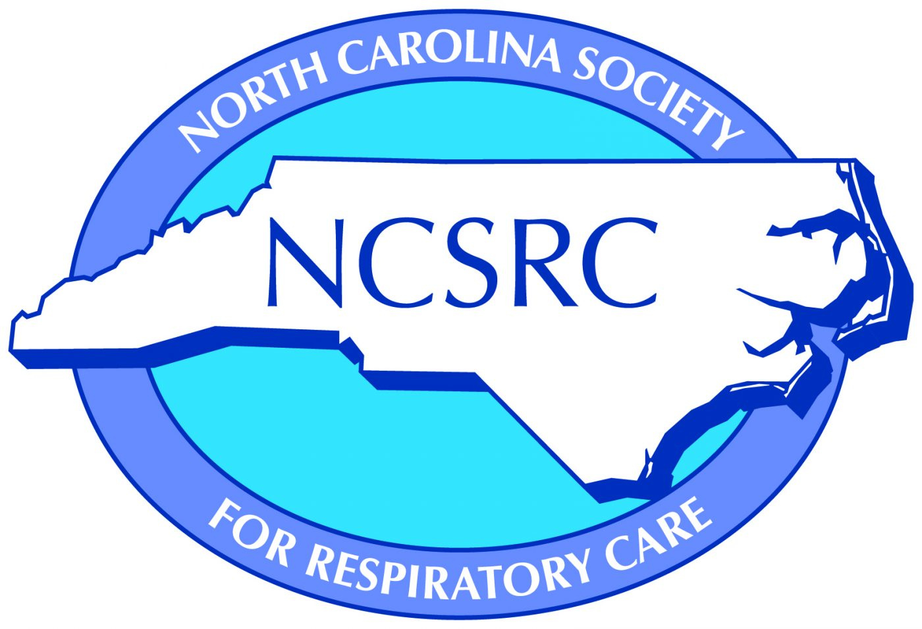

**2024 SPUTUM BOWL APPLICATION & ROSTER**

**Program Information:**

Respiratory Therapy Program:

Program Director Director’s Phone & e-Mail:

Program Director Signature:

Program Address:

City, State:

Zip Code:

**Team Name:**

**Team Captain:**

AARC Member Number:

Exp. Date:

e-Mail:

Projected Graduation Date:

**Additional Team Members:**

Member 1:

AARC Member Number:

Exp. Date:

e-Mail:

Projected Graduation Date:

Member 2:

AARC Member Number:

Exp. Date:

e-Mail:

Projected Graduation Date:

Member 3/Alternate Member:

AARC Member Number:

Exp. Date:

e-Mail:

Projected Graduation Date:

This application must be submitted to Dustin Smith at [dsmit423@charlotte.edu](mailto:dsmith423@charlotte.edu) no later than **August 30th by 11:59pm**. Responses after this date will not be accepted. Incomplete responses will not be accepted.

**PLEASE DO NOT SUBMIT ANYTHING TO THE AARC**. NCSRC will take care of submitting all necessary information to the AARC if National Sputum Bowl Competition is desired.

**OPTIONAL SPUTUM BOWL TEAM QUESTION SUBMISSION:**

Each affiliate entering the competition is asked to submit 5 visual images and/or 5 written questions for use in the Sputum Bowl. This option applies only once per year per participating team. Questions used in competition will be of both the traditional oral and visual types. They will be reviewed and selected by the Sputum Bowl Committee prior to competition.

* Questions must meet question category requirements
  + Anatomy and Physiology
  + Diagnostics
  + Pathology
  + Mechanical Ventilation
  + Neonatal and Pediatrics
  + Airway Management
  + Pharmacology
  + Gas Therapy
  + Acute/Critical Care
  + Humidity/Aerosol
  + Microbiology
  + Chemistry and Physics
  + Patient Assessment
  + Bronchial Hygiene
  + Patient Safety
  + Management
  + Cardiopulmonary Rehab
  + Home Care/Long Term Care -
  + History
* Must be submitted in a professional fashion of submitters choice
  + Ensure photos are visible
  + Original photos preferred, provide a source for any other images
* The definition of a “visual question” is one that CANNOT be answered without seeing the picture associated with it
* All questions must have an associated reference
  + Please supply original reference or refer to the reference guide located in Appendix A of the 2024 NCSRC Student Sputum Bowl Rules & Information document.
  + The photographs submitted for visual questions do not have to appear directly in the reference but the content of the image shall have the ability to be referenced
* Affiliates submitting photographs depicting patients are expected to have obtained signed releases authorizing the use of the photographs in Sputum Bowl competition. These documents must be available upon request by the NCSRC Sputum Bowl Committee. Note that it is not necessary to submit release forms with visual questions. Release forms should be obtained from your hospital or other employer.
* All visual questions MUST be new and original EACH year. Do NOT send in previously submitted visual questions.